**MCA273 DBT LAB 11 – Views -SECTION B – COMPONENT 2**

2147241-ANAGHA R

1. Database “university”

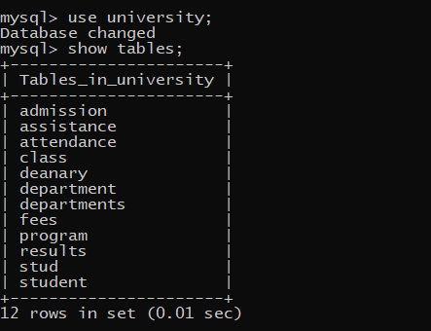

1. Table “student”

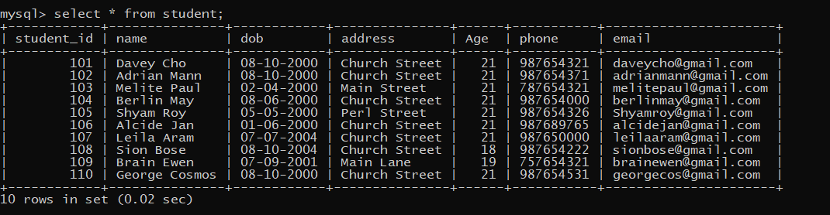

1. View “studentcontactinfo” on student

CREATE VIEW studentcontactinfo AS SELECT student_id,name,phone,email FROM student;

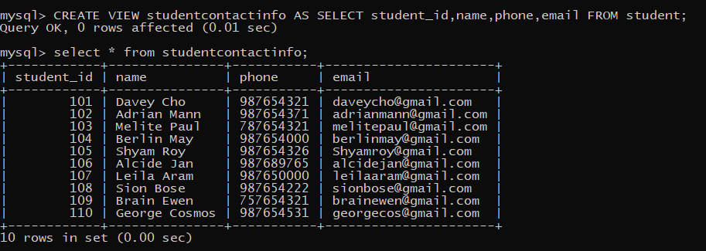

1. Table “department”

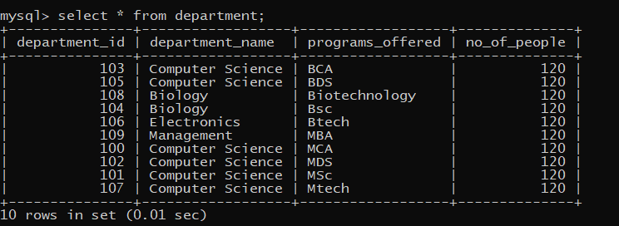

1. View “NamesLikeAorS” on department

